

5E ELECTRONIC CO.

Final Report

Ekim Kurtulmaz Kaan Denizer
Serkan Atrek

Gökhan Toker Mehmet İveynat

?. Summary of Development Plan

Our company 5E ELECTRONIC CO.’s schedule is given in the Appendix A. Our development plan consists of 8 main stages. They are, Formalization of the 5E Electronic Co., Researching the market, Electronic research followed the market research and we moved on with Vendor research and Business Plan. Next semester we are planning to move on to our project with the Implementation, Production and Marketing. At the end of the Spring semester 5E Electronic Co. are planning to conclude all its phases.
In the first semester, we have created our company, because we were five engineers we decided to name our company 5E Electronic Co. then we have researched the market and we have analyzed our competitors then we have analyzed the electronic parts, hardware and software analyzed were important during this phase. By the expenditure plan we have done the Vendor research and we moved on the Business plan writing. Through this stage all the company members worked hard and all future steps had taken into consideration, all the developing plans had been created in details.
In the second semester, Implementation is our milestone in our development plan. We are planning to do hardware and software implementations, then we are planning to do hardware and software integration then quality & controls are going to be our next step. After the simple production stage we are going to move on to production stage which is going to be very hard and we have to be careful during the production stage. While the implementation, production stages are going to move on, we are going to start to marketing of our product.
Whole development plan of our company is in Appendix A.
APPENDIX A
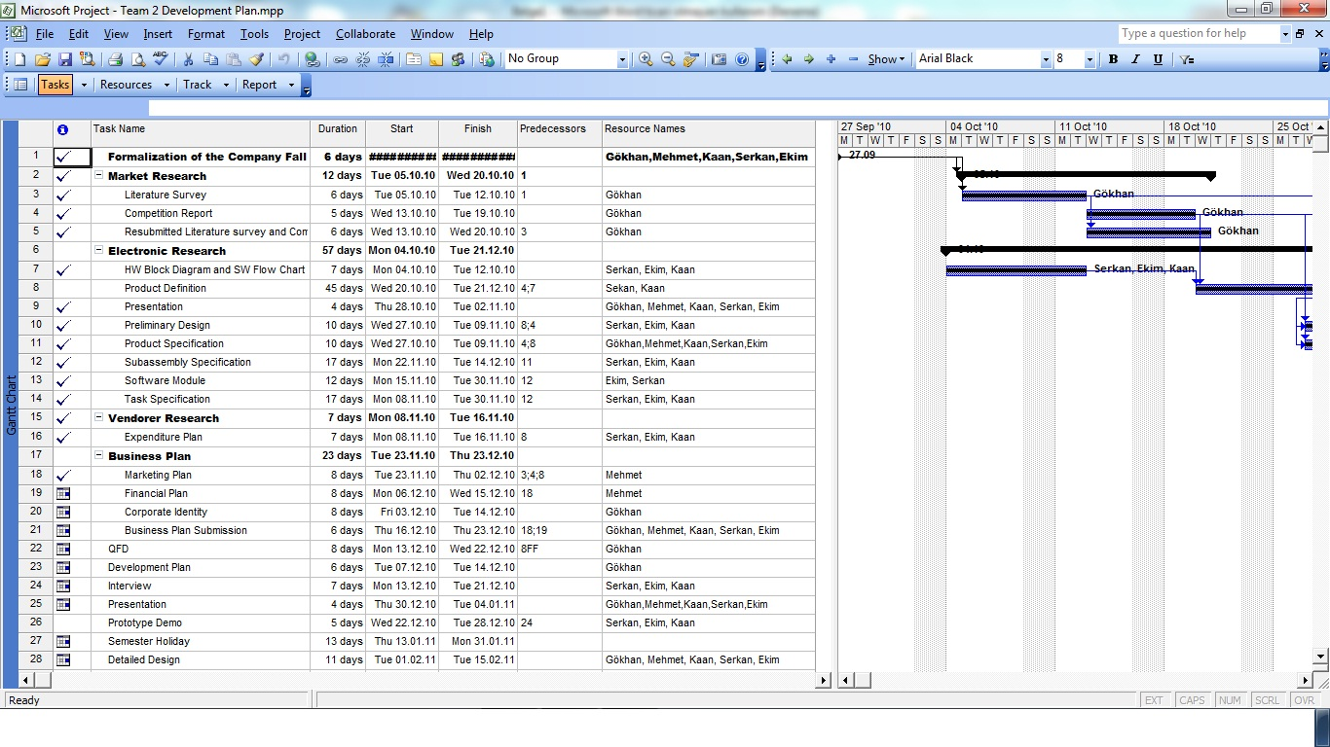
Table 1.A First Semester of Our Development Plan
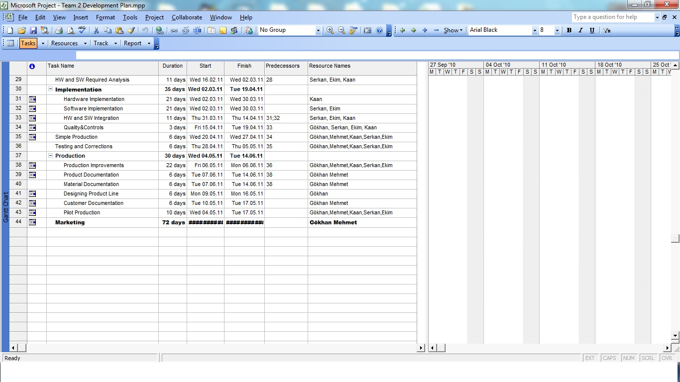
Table 2.A Second Semester of Our Development Plan

?. Summary of QFD
In order to clarify the complete cycle of our board, we have focused on the criteria’s which was mentioned in the quality function deployment. Those were;
- Creating a design that meets our customer needs.
- Conducting detailed product analyses of our product’s parts and components.
- Identifying the process necessary to be able to make the product.
- Upgrading the requirements of the product.
For investigating reliable and successful house of quality 5E Electronic Co. made customer surveys for our product Smart Board, and with the results of the surveys we conclude the “WHATS” which is the requirements of the customer for our product. Before the surveys we briefly told our product, we try to make an idea of affordable boards. Then we told about our competitors and the other smart board to make our survey objective and reliable. Also we told the other board’s features and prices of other boards. Then we request them to be objective in the surveys.
These surveys helped us to realize the recommendations, comments and demands of our product. We did our survey through phone, mail, and face to face. Our target was from different ages, sex and education. However, we specially try to ask our questions to instructors and student which are the potential users of our product.
USB and Internet Access: We should work on the USB and internet access to meet the demand of our customers which was multi functionality.
Meeting TSE Standart: TSE is a good reference for our product. Also it determines the reliability of our company.
Prices would be 1.000TL – 1.500 TL : Determines the price range of the product. Although it is between 1.000 TL to 1.500 TL our price around 900 TL.
24 Hours Online Service: Determines the service quality of our product.
Height and Width: It is related to the portability of our product. Which it is 200cm x 100cm.
Number of Colors: The colors of our product which we do not have alternative, we should work on it.
1 Year Guarantee: This is related to our company’s reputation, product’s quality and reliability.
Weight: Also it is related to the portability of the product. Our product is approximately 10 kg. It is the ideal kilos of a person would handle for a while.
Our surveys and Correlation Matrix is In APPENDIX B.

APPENDIXB 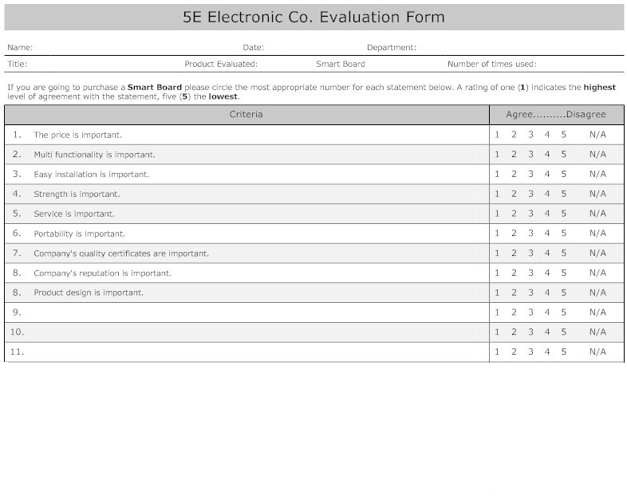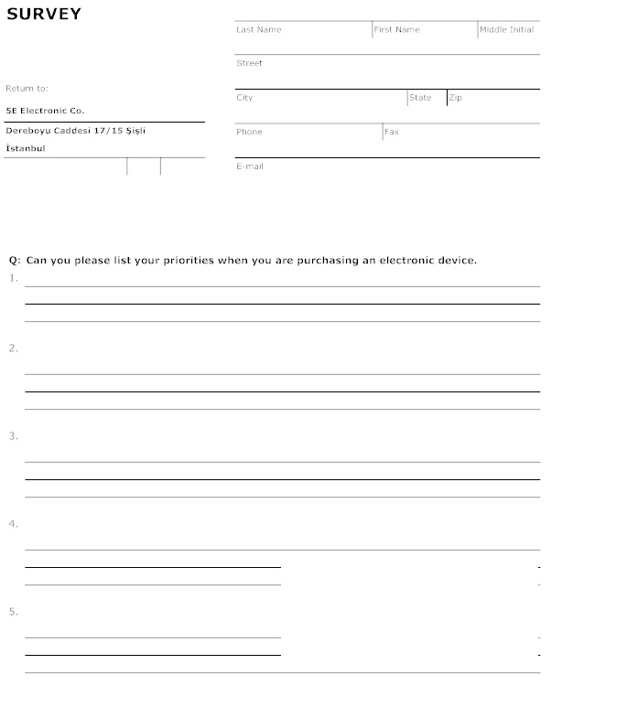

CORRELATION MATRIX
